Contents

Expected Value 1

Properties Of Expected Value 2

Example of expected Value 3

# Expected Value

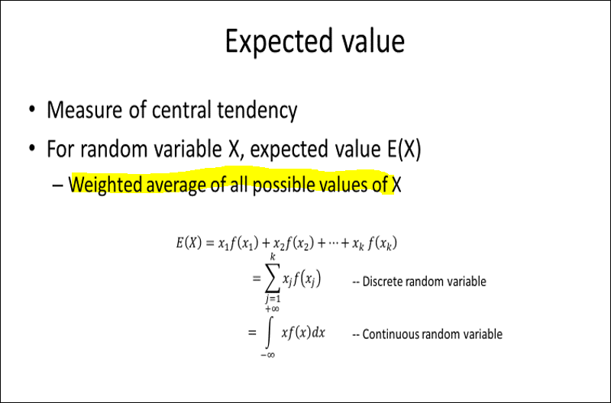

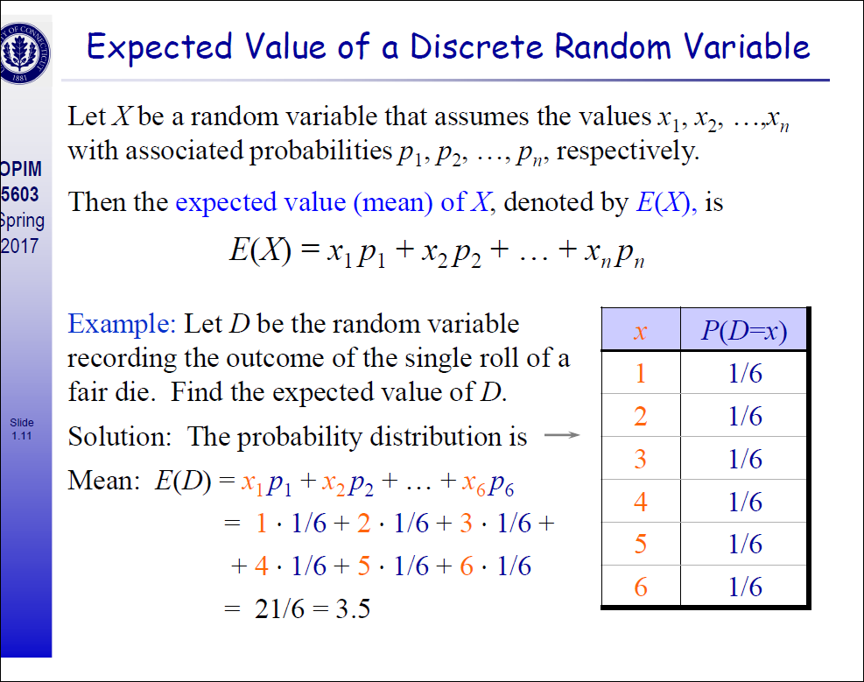

# Properties Of Expected Value

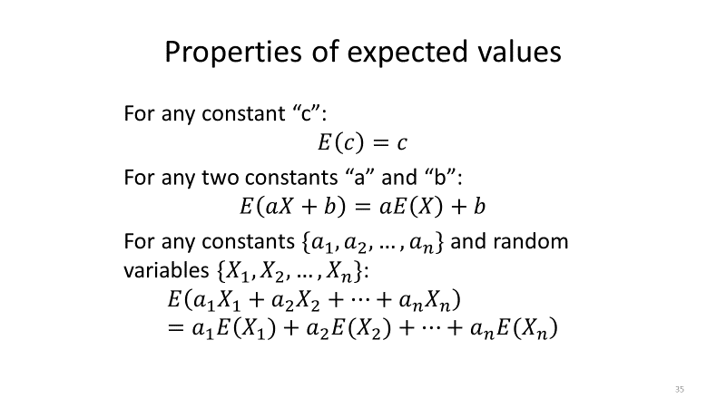

# Example of expected Value

